**PF-LAB PROJECT**

**LAB REPORT**

FINDING INVERSE OF A 2X2 MATRIX

Made by: -

Ahmed Hassan

210201072

**DESCRIPTION: -**

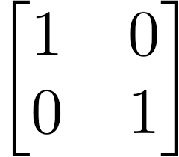The **inverse of a Matrix** is another matrix, which on multiplication with the given matrix gives the Identity Matrix:

To find the inverse we need to first find the determinant and adjoint of the matrix. Inverse can be calculated using a simple formula: -

**A-1=adj(A) x 1/|A|**

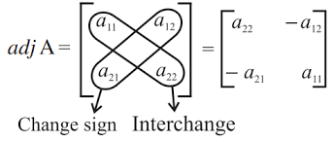

**Determinant(|A|) :** (a11 **x** a22) **-** (a12 **x** a21)

**About Program: -**

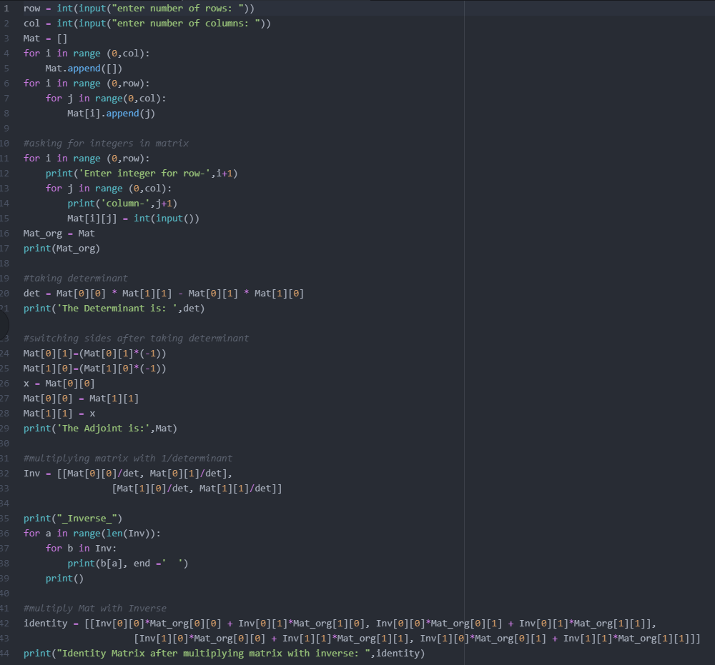 This program will ask the user first for the size of the matrix and then ask for each value that should be in the matrix. Then it will calculate the determinant and adjoint and print it. After that using the formula written above the program will calculate the inverse of the matrix and print it.

**Result after running: -**

